

**CS-114 - Fundamental of Programing**

**Lab Manual # 6**

**Lab Task**

Submitted To: Engr Muhammad Affan

Submitted By: Shahzaib Murtaza (466034)

Section: B

**1. Generate the Fibonacci sequence using nested loops.**

#include <iostream>

using namespace std;

int main() {

int n;

int a;

cout << "Number of terms : ";

cin >> n;

int b = 1;

int first_term= 0, second_term = 1;

bool flag = true;

while(flag == true){

while (b <= n) {

cout << first_term<< "\t";

a = first_term + second_term;

first_term = second_term;

second_term = a;

b++;

if (b == n){

flag = false;

}

}

}

return 0;

}

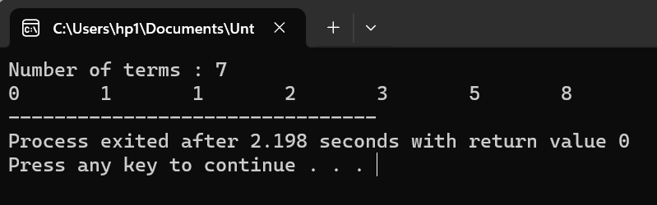

**2. Create Floyd’s triangle with nested loops.**

#include <iostream>

using namespace std;

int main()

{

int rows, a = 1, b = 1;

cout << "Enter number of rows: ";

cin >> rows;

for (int i = 1; i <= rows; i++){

a = 1;

while (a <= i){

cout << b << "\t";

b = b + 1;

a++;

}

cout << endl;

}

return 0;

}

